
W-16
11 PHYSICS ATAR
TEST 3: HEATING AND COOLING

NAME: MARK: 

DATA

Use the data sheet plus the following table.

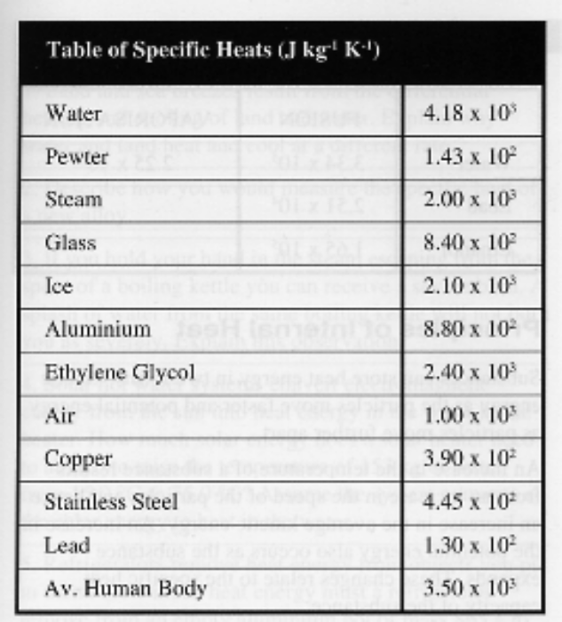

1. (a) Antifreeze has a specific heat less than that of water. What disadvantage would there be in using antifreeze in the cooling system of a car instead of a mixture of water and antifreeze?

(2)

(b) The radiator of a car is usually painted black. It is placed at the front of the engine behind the grille, and is usually made with lots of thin fins so that the air moves through it.

Explain how the three points underlined above assist in making the radiator efficient at
removing heat from the coolant of the engine.

(i) black

(ii) front of engine

(iii) lots of thin fins

(3)

2. A 5.00 x 10² g frozen pie is taken from a freezer at -5.00 °C. It is heated in a 6.50 x 10² W microwave.

(a) Estimate the amount of heat required to thaw the pie completely, assuming it is mainly made of water. State any assumptions you have made.
(Note: The pie is thawed when the water inside is just melted.)

(3)

(b) Estimate how much energy is needed to bring the thawed pie from 0.0 °C up to
80.0 °C.

(2)

(c) Assuming all of the energy supplied by the microwave oven is used to thaw and cook the pie, how long should it be cooked?

(3)

3. The heating curve for a sample of wax is given below. Heat was added at a constant rate.

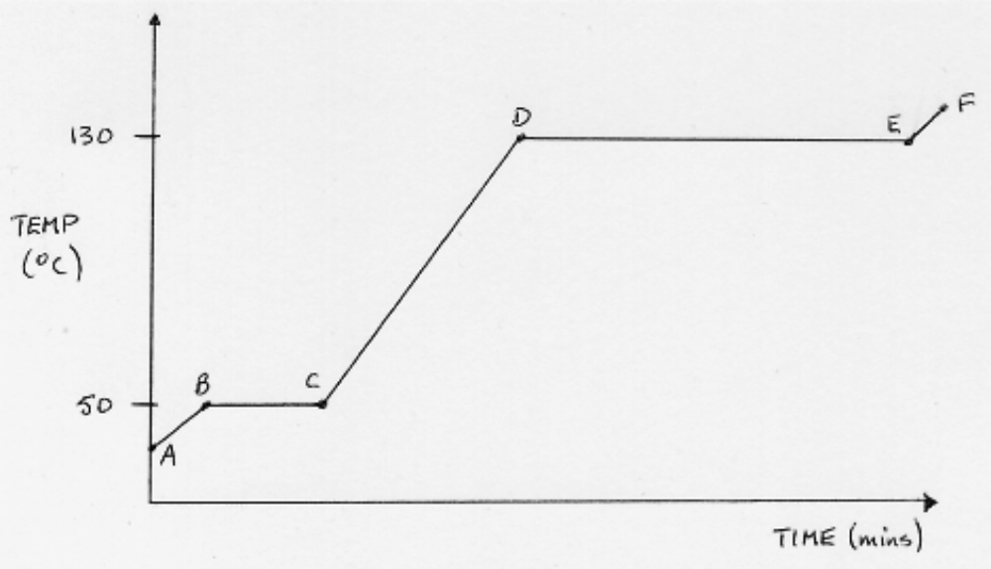

Use the Kinetic Theory of Matter to explain what is happening to the wax particles in the following questions.

(a) What is occurring in sections BC and DE as heat is added to the wax?

(2)

(b) Why is DE much longer than BC?

(2)

(c) What is happening during CD as heat is added?

(2)

(d) Label the diagram with the following labels.

solid, liquid, gas, solid + liquid, liquid + gas
(2)

4. A young footballer twisted his ankle slightly during a match. The physiotherapist for the
team sprayed a liquid from a can onto the ankle and the player immediately felt an intense cold. It lasted for about a minute until no fluid was visible on the skin.

Explain why the skin felt so cold so quickly.

(3)
5. During an experiment to determine the specific heat of glycerine, a 2.90 x 10² g piece of iron at 1.80 x 10² °C was placed carefully into a 1.00 x 10² g aluminium calorimeter containing 2.50 x 10² g of glycerine at 10.0 °C. The temperature rose to 38.0 °C. Determine the specific heat of the glycerine.

(4)

6. Many homes are now heated and cooled by reverse-cycle air conditioners.

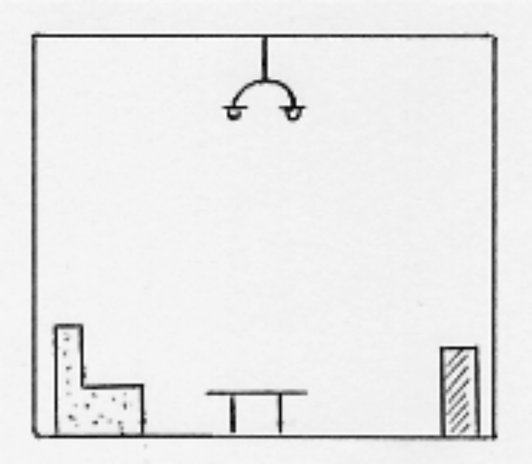

(a) On the diagram above, show where you should put a vent from the system so that the room is heated quickly and efficiently. Explain the reasons behind your decision.

(3)

(b) In a different colour, do the same as part (a) so that the room is cooled quickly and efficiently. Again, explain the reasons behind your decision.

(3)

